
COMPUTER SCIENCE AND ENGINEERING
Oct – 2026
ASSIGNMENT – 1
Course Code : CSA43
Course Name : INTERNET PROGRAMMING
Name : B KIRTHANAA
Register Number : 192324244
Max Marks: 50
Answer all the Questions
1 | Analyze using a case study the fundamental concepts of website development, HTML5 document structure, semantic elements and the important features introduced in HTML5. | (10) | (CO1) | (BL3)
2 | A Professional photogragraper creates a static web page with inline, embedded and external CSS with ingredients of CSS cascading rules, specificity and inheritance with real time web . | (10) | (CO1) | (BL3)
3 | Using a Go Daddy website template as a reference, explain how CSS3 features are used to design modern web pages. Discuss backgrounds, border images, colors, shadows and text effects with suitable CSS code examples | (10) | (CO1) | (BL3)
4 | Design a Contemporary web page design with implementation of CSS3 transformations, transitions and animations (marquee) with different types of transformations and demonstrate how animations can be implemented using key frames. | (10) | (CO1) | (BL3)
5 | Design an architecture, features and working principles of Progressive Web Applications (PWA). Discuss the roles of service workers, web app manifests, caching strategies and push notifications in providing an enhanced user experience. | (10) | (CO1) | (BL3)

Question 1: Case Study on Website Development and HTML5
Analyze using a case study the fundamental concepts of website development, HTML5 document structure, semantic elements and the important features introduced in HTML5. (10 marks, CO1, BL3)

SOLUTION:
Theory
Web and HTML background. The World Wide Web is an information system in which documents and resources are identified by URLs and transferred over HTTP. It was proposed by Tim Berners-Lee in 1989-1991, together with HTML (HyperText Markup Language), the language used to describe the structure of web documents. HTML is a markup language, not a programming language: it labels content (heading, paragraph, list, link, image) and leaves the browser to display it.
Elements, tags and attributes. An HTML element normally consists of a start tag, the content and an end tag, for example <p>Hello</p>. Attributes give extra information inside the start tag, such as href in <a href="index.html">. Void elements like <img>, <br> and <input> have no content and no end tag. Elements are either block level (start on a new line, such as <div>, <p>, <section>) or inline (stay inside a line, such as <span>, <a>, <strong>).
How a browser shows a page. The browser downloads the HTML, parses it into a tree called the DOM (Document Object Model), loads the CSS to build a style tree, combines them into a render tree, then calculates the layout and paints the pixels. JavaScript can change the DOM at any time, which is how pages become dynamic.
Evolution of HTML. HTML 4.01 (1999) and XHTML were followed by HTML5, which became a W3C Recommendation in October 2014 and is now maintained by the WHATWG as a living standard. HTML5 was designed to (1) replace plug-ins such as Flash with native audio, video and canvas, (2) give pages meaningful structure through semantic elements, (3) work on mobile devices as well as desktops, and (4) define clear error-handling rules so that all browsers treat the same markup in the same way.
Website development process. Developing a website is a sequence of requirement analysis, information architecture (sitemap), wireframing and visual design, coding, testing (functionality, usability, cross-browser, responsiveness), deployment on a host with a domain name, and regular maintenance. Good practice includes valid markup, meaningful titles, accessible alternative text for images, and mobile-first design.

Case study: Chennai Filter Coffee House
A traditional filter-coffee shop in Chennai wants a website where customers can see the menu, book a table and read about the shop. The site is structured with HTML5 semantic elements, styled with CSS3 and made interactive with a little JavaScript. The case study is used below to analyse each concept.
(a) Fundamental concepts of website development
Concept | Explanation | In the case study
Website and web server | A website is a set of linked web pages stored on a web server and reached through a domain name. | The coffee house pages are kept on a hosting server under the shop's domain name.
Client–server model, HTTP/HTTPS | The browser (client) sends an HTTP request and the server replies with HTML, CSS, JavaScript and images, which the browser renders. | A customer types the address; the browser downloads index.html and shows the menu.
URL, DNS and hosting | A URL gives the address of a resource, DNS converts the domain name into an IP address and hosting keeps the files online. | The domain name is mapped through DNS to the hosting server.
Front end and back end | The front end (HTML, CSS, JavaScript) runs in the browser; the back end (server code, database) processes and stores data. | The menu page is front end; saving a table reservation needs a back end.
Separation of structure, style and behaviour | HTML gives structure and content, CSS gives presentation and JavaScript gives behaviour. Keeping them separate makes a site easy to maintain. | HTML for sections and form, CSS for colours and layout, JavaScript for the canvas drawing and visit counter.
Development life cycle | Planning, design (wireframes), development, testing, deployment and maintenance. | Sitemap of Menu, Book a Table and About; tested on mobile and desktop browsers.

(b) HTML5 document structure
Every HTML5 page follows the same skeleton. The short <!DOCTYPE html> declaration switches the browser to standards mode, and the rest of the page is a tree of nested elements.
Part | Purpose
<!DOCTYPE html> | Declares an HTML5 document. It is much shorter than the long DOCTYPEs of older HTML versions.
<html lang="en"> | Root element. The lang attribute helps screen readers, translation tools and search engines.
<head> | Information that is not displayed: <meta charset="UTF-8"> (character set), <meta name="viewport"> (mobile scaling), <title>, <style> / <link> and <script>.
<body> | All visible content: headings, paragraphs, images, forms, tables and scripts.

(c) Semantic elements
Semantic elements describe the meaning of the content, not only its appearance. Before HTML5, layouts were built from many <div id="header"> boxes, which told browsers, search engines and screen readers nothing about their role.
Element | Meaning | Used in the case study
<header> | Introductory content such as logo and navigation | Shop name and links
<nav> | Main navigation links | Menu, Book a Table, About
<main> | The main, unique content of the page (only one per page) | Menu and booking sections
<section> | A thematic group of content, normally with a heading | Today's Menu, Book a Table
<article> | A self-contained, reusable item | Each dish (Filter Coffee, Masala Dosa)
<aside> | Side content related to the main content | About Us box with visit counter
<figure>, <figcaption> | An illustration with its caption | Canvas cup with Fig 1 caption
<footer> | Footer information of a page or section | Copyright line
<time>, <mark> | Machine-readable time; highlighted text | Serving time 8:00 AM; "Bestseller" label

Advantages: better accessibility for screen readers, better search-engine understanding, cleaner and more readable code, and easier maintenance than a page made only of <div> tags.
(d) Important features introduced in HTML5
Feature | Description | In the case study
Semantic elements | header, nav, main, section, article, aside, footer and others give meaning to the layout. | Whole page layout
New form input types and attributes | email, date, number, range, search, tel, url and color inputs; placeholder, required, min, max, list/datalist. The browser validates the data without JavaScript. | Booking form: email, date, number, datalist
Audio and video | <audio> and <video> play media natively, so plug-ins such as Flash are not needed. | Not used; e.g. <video controls src="making.mp4">
Canvas and SVG | <canvas> draws 2D graphics using JavaScript; SVG draws scalable vector graphics. | Coffee cup drawn on canvas
Web storage | localStorage and sessionStorage keep data in the browser; larger and simpler than cookies. | Visit counter in the About box
Geolocation API | navigator.geolocation gives the user's position with permission. | Could show the nearest outlet
Drag and drop, Web Workers, WebSockets | Native drag and drop, background scripts and real-time two-way communication. | Not used
Offline and app features | Service workers and the web app manifest allow offline, installable web apps (see Question 5). | Not used here
Obsolete tags removed | Presentational tags such as <font> and <center> are dropped; CSS is used for styling. | CSS in the <style> block

(e) Implementation of the case study
HTML CODE (index.html):
<!DOCTYPE html>
<html lang="en">
<head>
<meta charset="UTF-8">
<meta name="viewport" content="width=device-width, initial-scale=1.0">
<title>Chennai Filter Coffee House</title>
<style>
body { font-family: Arial, sans-serif; margin: 0; background: #faf6f0; color: #3b2a1a; }
header, footer { background: #5a3825; color: #fff; padding: 12px 24px; }
header { display: flex; justify-content: space-between; align-items: center; }
header h1 { margin: 0; font-size: 1.5rem; }
nav a { color: #f4d8a8; margin-left: 16px; text-decoration: none; }
.wrap { display: flex; gap: 16px; padding: 16px 24px; }
main { flex: 3; }
aside { flex: 1; background: #fff; padding: 12px; border-radius: 6px; align-self: flex-start; }
section, article { background: #fff; padding: 12px; border-radius: 6px; margin-bottom: 12px; }
article { border-left: 4px solid #c68b59; }
figcaption { font-size: .8rem; color: #777; }
input, button { padding: 6px; margin: 3px 0; }
footer { text-align: center; }
</style>
</head>
<body>
<header>
<h1>Chennai Filter Coffee House</h1>
<nav><a href="#menu">Menu</a><a href="#book">Book a Table</a><a href="#about">About</a></nav>
</header>
<div class="wrap">
<main>
<section id="menu">
<h2>Today's Menu</h2>
<article>
<h3>Filter Coffee <mark>Bestseller</mark></h3>
<p>Fresh decoction with hot milk, served 7:00 AM to 10:00 PM.</p>
<figure>
<canvas id="cup" width="130" height="70"></canvas>
<figcaption>Fig 1: Cup drawn with the HTML5 canvas element</figcaption>
</figure>
</article>
<article>
<h3>Masala Dosa</h3>
<p>Breakfast special, served from <time datetime="08:00">8:00 AM</time> to 11:00 AM.</p>
</article>
</section>
<section id="book">
<h2>Book a Table</h2>
<form>
<input type="text" placeholder="Your name" required><br>
<input type="email" placeholder="Email address" required><br>
<input type="date"> <input type="number" min="1" max="10" value="2"><br>
<input list="slots" placeholder="Choose a time slot">
<datalist id="slots"><option value="Breakfast"><option value="Lunch"><option value="Dinner"></datalist><br>
<button type="submit">Reserve</button>
</form>
</section>
</main>
<aside id="about">
<h3>About Us</h3>
<p>Serving traditional filter coffee since 1995.</p>
<p id="visits"></p>
</aside>
</div>
<footer><p>&copy; 2026 Chennai Filter Coffee House</p></footer>
<script>
const g = document.getElementById("cup").getContext("2d");
g.fillStyle = "#6f4e37"; g.fillRect(20, 15, 70, 45);
g.fillStyle = "#c68b59"; g.fillRect(20, 15, 70, 10);
g.beginPath(); g.arc(98, 37, 14, -Math.PI / 2, Math.PI / 2);
g.lineWidth = 6; g.strokeStyle = "#6f4e37"; g.stroke();
let n = Number(localStorage.getItem("visits") || 0) + 1; // Web Storage
localStorage.setItem("visits", n);
document.getElementById("visits").textContent = "Your visits to this page: " + n;
</script>
</body>
</html>

OUTPUT:
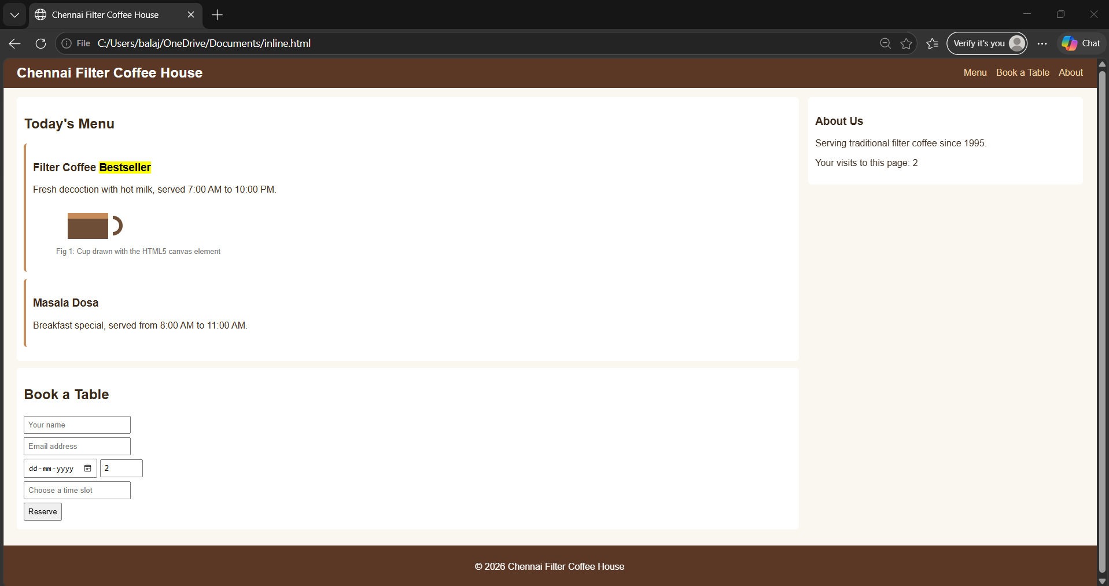
Fig 1.1: Chennai Filter Coffee House page in the browser

Explanation of the output
- The header holds the shop name and <nav> links; the <main> area contains two sections; the About <aside> stands beside it and the <footer> closes the page.
- The cup is drawn on the HTML5 <canvas>. The booking form shows a native date picker, a number spinner and a datalist, and required with type="email" stops an invalid form from being submitted.
- The visit counter uses web storage and increases every time the page is reloaded.
Conclusion: HTML5 gives a meaningful document structure through semantic elements and adds built-in features (forms, graphics, storage, media) that earlier needed plug-ins or extra scripts.

Question 2: Static Photographer Web Page with Inline, Embedded and External CSS
A Professional photogragraper creates a static web page with inline, embedded and external CSS with ingredients of CSS cascading rules, specificity and inheritance with real time web. (10 marks, CO1, BL3)
SOLUTION:
A photographer, Lens & Light Studio, needs a static portfolio page. The page uses all three ways of adding CSS, and the same page is used to demonstrate the cascade, specificity and inheritance.

Theory
What is CSS? Cascading Style Sheets (CSS) is the language that describes the presentation of an HTML document: colours, fonts, spacing, layout and effects. Its purpose is the separation of content (HTML) from presentation (CSS), so that one stylesheet can control hundreds of pages and the look of a site can be changed without touching the content.
Syntax. A CSS rule has a selector and a declaration block: selector { property: value; }. Common selectors are element (p), class (.note), ID (#hero), attribute (a[target]), descendant (nav a), child (ul > li), group (h1, h2) and pseudo-classes (a:hover). Values may be keywords, lengths (px, em, rem, %), colours or functions.
The box model. Every element is drawn as a rectangular box made of content, padding, border and margin. box-sizing: border-box makes the declared width include padding and border, which simplifies layouts.
How the browser resolves styles. For each element the browser collects all declarations that match, decides which one wins (cascade), fills missing values from the parent for inherited properties, and otherwise uses the default (initial) value. The result passes through the stages specified, computed, used and actual value before the element is painted. The cascade considers origin (browser, user, author), importance, specificity and order of appearance.
Why three methods exist. Inline CSS applies directly to one tag and has the highest priority among normal rules; embedded CSS lives in a <style> block and affects one page; external CSS is a separate .css file linked with <link> and shared by the whole site. External CSS is preferred in professional work because the browser caches it, it is easy to maintain, and it keeps HTML clean. A photographer's portfolio is a typical case: one shared stylesheet gives all gallery pages the same look, with small page-specific rules embedded and occasional inline adjustments.
A photographer, Lens & Light Studio, needs a static portfolio page. The page uses all three ways of adding CSS, and the same page is used to demonstrate the cascade, specificity and inheritance.

(a) Three ways of applying CSS
Type | How it is written | Advantages | Limitations and real-web use
Inline | style attribute on one element: <p style="color:#f4b942;"> | Highest priority; quick one-off change. | Cannot be reused and mixes content with design. Seen in HTML e-mails and page-builder output.
Embedded (internal) | <style> block inside <head> | No extra file request; applies to the whole page. | Not shared between pages. Used for small "critical CSS" that helps the first screen render fast.
External | <link rel="stylesheet" href="style.css"> | One file styles many pages; cached by the browser; best for maintenance. | One extra request. Used by most real sites, including CDN files such as Bootstrap and Google Fonts.

(b) CSS cascading rules
When several rules set the same property on the same element, the browser chooses the winner using the cascade, in this order:
- Origin and importance: browser default styles are weaker than author styles, and a declaration marked !important beats normal declarations.
- Specificity: the more specific selector wins.
- Source order: if specificity is equal, the rule written last wins. An embedded <style> written after the <link> therefore overrides the external file.
(c) Specificity
Selector type | Example | Weight (inline, ID, class, element)
Universal | * | 0, 0, 0, 0
Element / pseudo-element | p, h1 | 0, 0, 0, 1
Class / attribute / pseudo-class | .note, a:hover | 0, 0, 1, 0
ID | #c1 | 0, 1, 0, 0
Inline style | style="..." | 1, 0, 0, 0
Combined selectors | p.note and #hero h2 | 0, 0, 1, 1 and 0, 1, 0, 1

The weights are compared from left to right, so one ID beats any number of classes. !important overrides all of them.
(d) Inheritance
- Inherited by default: color, font-family, font-size, line-height, text-align, visibility, cursor.
- Not inherited: border, margin, padding, background, width, height, display.
- The keyword inherit forces inheritance and initial resets a property to its default value.
- In the page, the .quote paragraph defines no font or colour and receives Georgia and #333 from body. The dashed border of .gallery is not passed to the .photo boxes inside it.
(e) CSS on real websites
- Open any website, press F12 in Chrome and select Elements, then the Styles pane. It lists every rule that matches the chosen element in priority order, overridden declarations are struck through and the Computed tab shows the final inherited values.
- Real sites combine the three methods: external stylesheets (often from a CDN), a small embedded critical-CSS block and inline styles generated by scripts or page builders. This layering is the cascade at work.
- Themes and frameworks are customised by loading an extra stylesheet last or by using more specific selectors, instead of editing the original files.
(f) Implementation
HTML CODE (index.html) - embedded and inline CSS:
<!DOCTYPE html>
<html lang="en">
<head>
<meta charset="UTF-8">
<meta name="viewport" content="width=device-width, initial-scale=1.0">
<title>Lens &amp; Light Studio</title>
<!-- 1. EXTERNAL CSS -->
<link rel="stylesheet" href="style.css">
<!-- 2. EMBEDDED CSS -->
<style>
h1 { color: #f1c40f; }
.b { color: #2e7d32; }
#c1 { color: #c62828; }
.c { color: #2e7d32; }
.e { color: #ef6c00 !important; }
.photo { font-size: 0.9rem; }
</style>
</head>
<body>
<header>
<h1>Lens &amp; Light Studio</h1>
<!-- 3. INLINE CSS -->
<p class="tagline" style="color:#f4b942;">Capturing moments, one frame at a time</p>
</header>
<main>
<h2>Cascade and Specificity Demo</h2>
<ul>
<li class="a">1. External rule only: blue</li>
<li class="b">2. Embedded overrides external (same specificity, later rule wins): green</li>
<li class="c" id="c1">3. ID selector beats class selector, although .c comes later: red</li>
<li class="d" style="color:#8e24aa;">4. Inline style beats the class selector: purple</li>
<li class="e" style="color:#8e24aa;">5. !important beats the inline style: orange</li>
</ul>
<h2>Portfolio</h2>
<section class="gallery">
<div class="photo portrait">Portrait</div>
<div class="photo wedding">Wedding</div>
<div class="photo nature">Nature</div>
</section>
<p class="quote">Inheritance: this paragraph takes its font and colour from body.</p>
</main>
<footer>&copy; 2026 Lens &amp; Light Studio</footer>
</body>
</html>

CSS CODE (style.css) - external CSS:
/* style.css - external stylesheet */
body { font-family: Georgia, serif; color: #333; background: #fafafa; margin: 0; }
header { background: #111; padding: 18px; text-align: center; }
h1 { color: #4a90d9; letter-spacing: 2px; margin: 0 0 6px; }
.tagline { margin: 0; font-style: italic; }
main { padding: 16px 24px; }
.a, .b, .c, .d, .e { color: #1565c0; }
.gallery { display: grid; grid-template-columns: repeat(3, 1fr); gap: 12px;
border: 2px dashed #bbb; padding: 12px; }
.photo { height: 100px; border-radius: 6px; color: #fff; padding: 8px;
display: flex; align-items: flex-end; }
.portrait { background: linear-gradient(135deg, #614385, #516395); }
.wedding { background: linear-gradient(135deg, #cc2b5e, #753a88); }
.nature { background: linear-gradient(135deg, #11998e, #38ef7d); }
.quote { font-style: italic; }
footer { background: #111; color: #aaa; text-align: center; padding: 10px; }

OUTPUT:
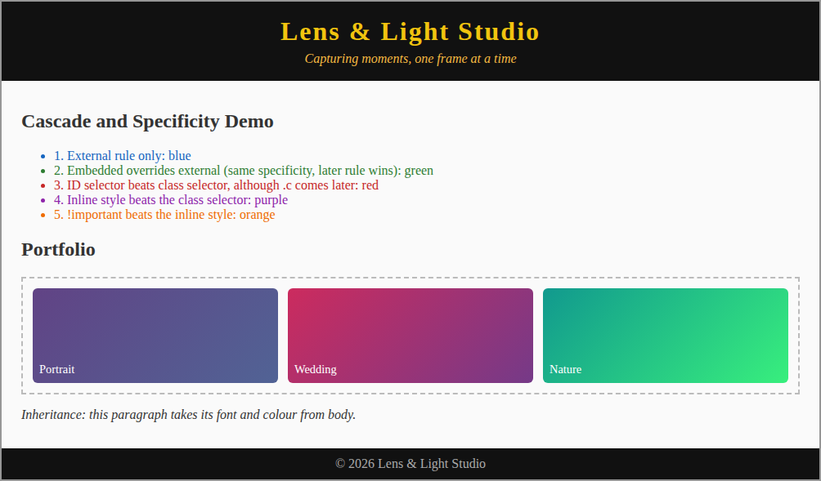
Fig 2.1: Photographer page showing the cascade results

Explanation of the output
Item | Final colour | Reason
1 | Blue | Only the external rule .a applies.
2 | Green | The embedded .b has the same specificity (0,0,1,0) as the external rule but is written later, so it wins.
3 | Red | #c1 (0,1,0,0) beats .c (0,0,1,0) even though .c comes later.
4 | Purple | The inline style (1,0,0,0) beats the class selector.
5 | Orange | !important in the embedded CSS beats the inline style.
Heading h1 | Gold | The embedded h1 rule is written after the external h1 rule with equal specificity, so blue is overridden.

Conclusion: the three CSS methods can be mixed on one page. The cascade (importance, specificity and order) decides the final style and inheritance saves repeating text styles on every element.

Question 3: CSS3 Features for Modern Web Pages (GoDaddy Template Reference)
Using a Go Daddy website template as a reference, explain how CSS3 features are used to design modern web pages. Discuss backgrounds, border images, colors, shadows and text effects with suitable CSS code examples. (10 marks, CO1, BL3)
SOLUTION:
Theory
CSS3 and its modules. CSS3 is not one large specification but a set of independent modules that are developed and released separately, for example Selectors, Backgrounds and Borders, Color, Text, Fonts, Transforms, Transitions, Animations, Flexible Box, Grid Layout and Media Queries. This modular approach let browsers add new features quickly, and most of these modules are now widely supported.
Why CSS3 matters for modern design. Before CSS3, effects such as rounded corners, drop shadows, gradients and custom fonts needed extra images, tables or scripts. CSS3 produces them in code, which gives smaller pages, faster loading, sharper graphics on every screen resolution and designs that are easy to change.
Website builders and templates. Website builders such as GoDaddy provide ready-made templates made of reusable sections (hero banner, services, gallery, testimonials, contact and footer). Each section is styled by CSS, and the user changes only the text, images and colours. Understanding the CSS behind a template allows it to be customised beyond what the builder's menus offer.
Design principles used in modern pages. Modern pages follow a card-based layout, generous spacing, a limited colour palette, high-contrast text, large hero images with an overlay for readable headings, and subtle depth created by shadows. For accessibility, the WCAG guideline asks for a contrast ratio of at least 4.5:1 for normal text, so a dark overlay is placed over a photo before white text is added.
Browser support and fallbacks. Older browsers needed vendor prefixes such as -webkit- and -moz- for new properties. Today most CSS3 properties work without them, but -webkit-background-clip: text is still written for compatibility. A safe practice is to give a plain fallback value first (for example a solid colour) and the advanced value after it.
Performance. Large blur values on box-shadow or text-shadow can slow drawing on weak devices, so shadows should be used with moderation, and gradients are preferred to large background images because they need no download.
Business templates in GoDaddy Website Builder follow a common modern pattern: a full-width hero banner with a background and overlay, a bold headline, a rounded call-to-action button, service cards with soft shadows and a footer. This pattern is used as the reference, and a bakery page, Sweet Crumbs Bakery, is built to show how CSS3 creates each part.

Business templates in GoDaddy Website Builder follow a common modern pattern: a full-width hero banner with a background and overlay, a bold headline, a rounded call-to-action button, service cards with soft shadows and a footer. This pattern is used as the reference, and a bakery page, Sweet Crumbs Bakery, is built to show how CSS3 creates each part.
Template part | CSS3 features used
Hero banner | Layered backgrounds, gradients, background-size
Headline | text-shadow, text-transform, letter-spacing
Call-to-action button | border-radius, hsla() colour, box-shadow
Service cards | box-shadow (multiple shadows), border-radius
Offer strip | border-image
Highlights | Gradient text, text-overflow, glow effect

(a) Backgrounds
CSS3 allows several background layers in one declaration (the first layer is on top), gradients created by linear-gradient(), radial-gradient() and repeating-linear-gradient(), and control through background-size (cover, contain, length), background-position, background-origin and background-clip. A semi-transparent gradient laid over a photo is the usual way a template keeps the headline readable.
background: linear-gradient(rgba(0,0,0,.5), rgba(0,0,0,.5)), url("hero.jpg");
background-size: cover;
background-position: center;

(b) Border images
border-image draws the border from an image or gradient. Its parts are border-image-source, -slice, -width, -outset and -repeat. Templates use it for decorative frames around offers and quotes.
border: 8px solid;
border-image: linear-gradient(45deg, #f59e0b, #dc2626, #7c3aed) 1;
/* image version: border-image: url("frame.png") 30 round; */

(c) Colors
Besides names and hex codes, CSS3 adds rgba() and hsla() with an alpha (transparency) value, hsl() (hue, saturation, lightness, which makes it easy to create matching shades), opacity and currentColor.
color: hsl(40, 100%, 90%); /* light cream text */
background: hsla(14, 90%, 45%, .95); /* almost opaque orange */
box-shadow: 0 6px 14px rgba(0,0,0,.35); /* 35% black */

(d) Shadows
box-shadow: x-offset y-offset blur spread colour [inset] adds depth to boxes, and several shadows can be combined with commas. text-shadow: x y blur colour does the same for text and, with a large blur, creates a glow.
box-shadow: 0 2px 4px rgba(0,0,0,.12), 0 10px 24px rgba(194,65,12,.18);
text-shadow: 2px 2px 0 #7c2d12, 4px 4px 8px rgba(0,0,0,.5);

(e) Text effects
CSS3 provides text-shadow, text-transform, letter-spacing, text-overflow: ellipsis (with overflow: hidden and white-space: nowrap), word-wrap, web fonts through @font-face and gradient text using background-clip: text.
background: linear-gradient(90deg, #f59e0b, #dc2626);
-webkit-background-clip: text; background-clip: text; color: transparent;
white-space: nowrap; overflow: hidden; text-overflow: ellipsis;

(f) Implementation
HTML & CSS CODE (index.html):
<!DOCTYPE html>
<html lang="en">
<head>
<meta charset="UTF-8">
<meta name="viewport" content="width=device-width, initial-scale=1.0">
<title>Sweet Crumbs Bakery - CSS3 Features</title>
<style>
* { box-sizing: border-box; }
body { margin: 0; font-family: "Trebuchet MS", sans-serif; color: #3d2b1f; background: #fff8f0; }

/* 1. BACKGROUNDS: layered backgrounds, gradients, background-size */
.hero { text-align: center; padding: 44px 20px; color: #fff;
background: linear-gradient(rgba(60,20,0,.55), rgba(60,20,0,.55)),
repeating-linear-gradient(45deg, #d97706 0 16px, #c2410c 16px 32px);
background-size: cover; background-position: center; }

/* 2. COLORS: hex, rgba(), hsl(), hsla() */
.hero p { color: hsl(40, 100%, 90%); margin: 0 0 18px; }
.btn { display: inline-block; padding: 10px 26px; border-radius: 30px; color: #fff;
text-decoration: none; background: hsla(14, 90%, 45%, .95);
box-shadow: 0 6px 14px rgba(0,0,0,.35), inset 0 -3px 0 rgba(0,0,0,.25); }

/* 3. TEXT EFFECTS and TEXT SHADOW */
.hero h1 { font-size: 2.3rem; margin: 0 0 8px; text-transform: uppercase; letter-spacing: 3px;
text-shadow: 2px 2px 0 #7c2d12, 4px 4px 8px rgba(0,0,0,.5); }

/* 4. BOX SHADOW on cards */
.cards { display: flex; gap: 16px; padding: 24px; }
.card { flex: 1; padding: 16px; background: #fff; border-radius: 10px;
box-shadow: 0 2px 4px rgba(0,0,0,.12), 0 10px 24px rgba(194,65,12,.18); }
.card h3 { margin-top: 0; color: hsl(18, 80%, 35%); }

/* 5. BORDER IMAGE (gradient used as the border image) */
.offer { margin: 0 24px 24px; padding: 16px; text-align: center; background: #fff;
border: 8px solid; border-image: linear-gradient(45deg, #f59e0b, #dc2626, #7c3aed) 1; }

/* 6. MORE TEXT EFFECTS */
.effects { display: flex; gap: 16px; padding: 0 24px 24px; align-items: center; }
.gradient-text { font-size: 1.8rem; font-weight: bold; background: linear-gradient(90deg, #f59e0b, #dc2626);
-webkit-background-clip: text; background-clip: text; color: transparent; }
.clip { width: 220px; white-space: nowrap; overflow: hidden; text-overflow: ellipsis;
border: 1px dashed #c2410c; padding: 6px; }
.neon { background: #1c1917; color: #fde68a; padding: 10px 16px; border-radius: 6px;
text-shadow: 0 0 6px #fbbf24, 0 0 14px #f59e0b; }
</style>
</head>
<body>
<section class="hero">
<h1>Sweet Crumbs Bakery</h1>
<p>Fresh cakes, cookies and breads baked every morning</p>
<a class="btn" href="#">Order Now</a>
</section>
<section class="cards">
<div class="card"><h3>Cakes</h3><p>Custom birthday and wedding cakes.</p></div>
<div class="card"><h3>Breads</h3><p>Sourdough, multigrain and buns.</p></div>
<div class="card"><h3>Cookies</h3><p>Butter, oat and chocolate chip.</p></div>
</section>
<div class="offer"><strong>Festival Offer:</strong> 20% off on all cakes this week</div>
<section class="effects">
<span class="gradient-text">Gradient Text</span>
<div class="clip">This long line of text is cut with an ellipsis</div>
<span class="neon">Neon Glow</span>
</section>
</body>
</html>

OUTPUT:
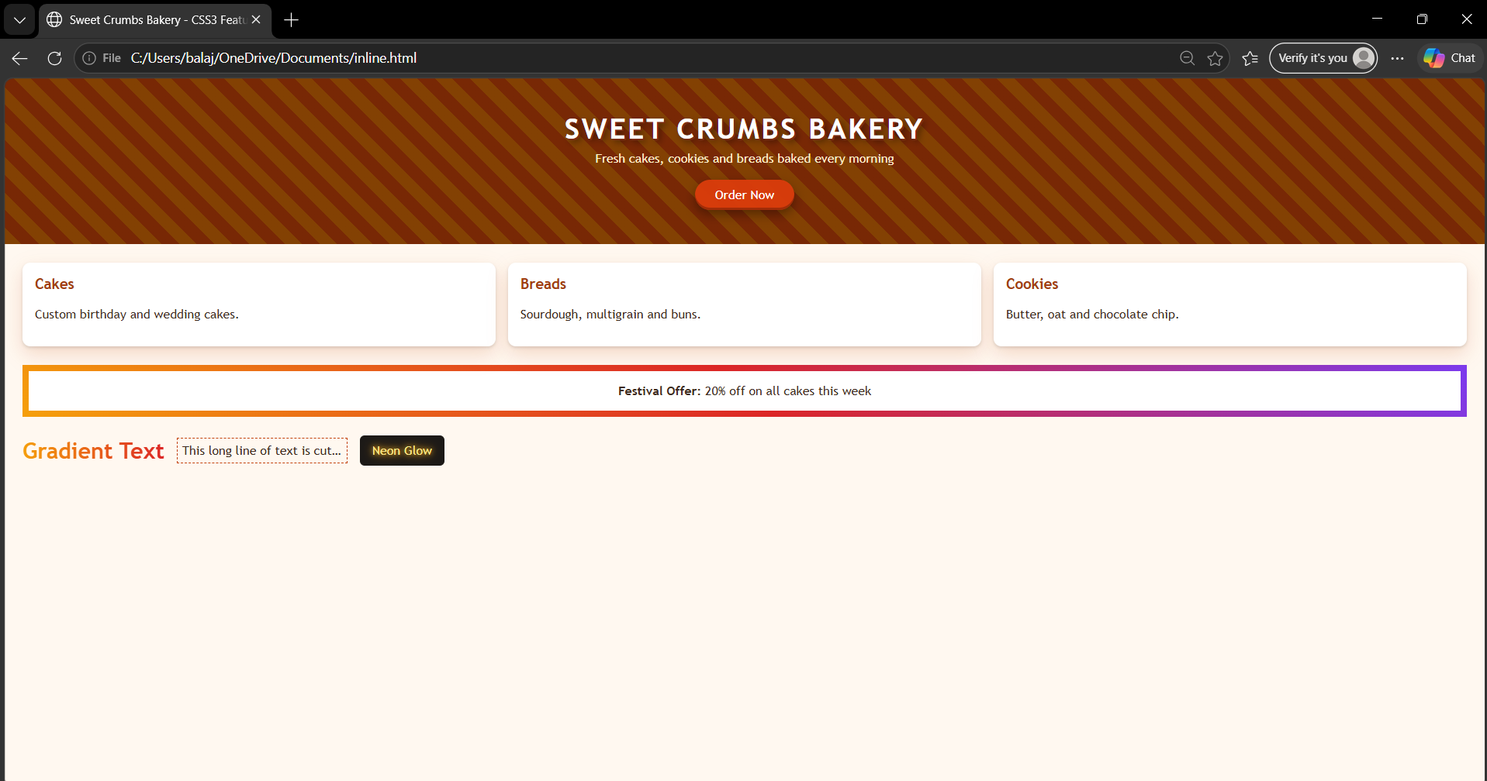
Fig 3.1: Sweet Crumbs Bakery page using CSS3 features
Explanation of the output
Part of the output | CSS3 features seen
Hero banner | A dark overlay gradient over a striped repeating-linear-gradient background (layered backgrounds, background-size: cover).
Headline | Uppercase text with letter spacing and a two-layer text-shadow for a raised look.
Order Now button | Rounded corners, hsla() colour, an outer shadow and an inset shadow for a pressed edge.
Cakes, Breads, Cookies cards | Rounded corners and two stacked box-shadow values; headings use an hsl() colour.
Festival Offer strip | border-image with a three-colour gradient border.
Last row | Gradient text, a line cut with an ellipsis and a neon glow made from text-shadow.

Conclusion: backgrounds, border images, colours, shadows and text effects let a template look modern using only CSS, without image editing or extra scripts.

Question 4: CSS3 Transformations, Transitions and Animations (Marquee)
Design a Contemporary web page design with implementation of CSS3 transformations, transitions and animations (marquee) with different types of transformations and demonstrate how animations can be implemented using key frames. (10 marks, CO1, BL3)
SOLUTION:
Theory
Role of motion in a user interface. Motion draws attention, gives feedback (a button reacting to a hover), shows relationships (a menu sliding from its button) and makes a page feel alive. Overuse, however, distracts users and can cause discomfort, so motion must be purposeful, short (usually 150 to 500 ms) and switchable for users who prefer reduced motion (@media (prefers-reduced-motion: reduce)).
Coordinate system of transforms. CSS transforms work on a coordinate system with the x-axis to the right, the y-axis downwards and the z-axis towards the viewer. The point around which an element is rotated or scaled is set by transform-origin (centre by default). Several functions can be combined in one declaration and are applied from right to left, so translate(50px) rotate(30deg) is different from rotate(30deg) translate(50px). Internally every transform is converted to a 3 x 3 (2D) or 4 x 4 (3D) matrix, which is what matrix() and matrix3d() express directly. A transform does not change the space the element occupies in the layout, so neighbouring elements do not move.
3D effects. The perspective property (or the perspective() function) sets the distance between the viewer and the z = 0 plane; a smaller value gives a stronger 3D effect. transform-style: preserve-3d lets child elements keep their own 3D positions, and backface-visibility: hidden hides the reverse side of an element, which is how a flip card is built from a front and a back face.
Timing functions. Speed over time is controlled by a timing function: linear (constant), ease (slow-fast-slow, the default), ease-in, ease-out, ease-in-out, steps() (jumps) and cubic-bezier(x1, y1, x2, y2) for custom curves. Natural-looking motion usually starts or ends slowly.
Rendering pipeline and performance. To show a frame the browser performs style calculation, layout, paint and composite. Changing properties such as width, height, top or margin triggers layout and paint again, which is expensive. Changing transform and opacity can be handled by the GPU in the composite stage only, so the animation runs smoothly at about 60 frames per second. For this reason movement is created with transform instead of left or top.
CSS compared with JavaScript animation. CSS transitions and keyframes are declarative, simple and optimised by the browser, and suit most interface effects. JavaScript (including the Web Animations API) is used when the animation depends on user input, needs precise control or has to be paused, reversed or chained in complex ways.
History of the marquee. The <marquee> element was a browser-specific tag that scrolled text. It was never standardised and is obsolete, and CSS animation is the standard replacement, giving full control over speed, direction, looping and pausing.
A contemporary event page, Neon Tech Fest 2026, is designed on a dark theme. It has a scrolling marquee, a glowing title, boxes showing 2D and 3D transformations, hover transitions, keyframe animations and a 3D flip card.
(a) Types of transformations
Function | Type | Effect | Example
translate(x, y), translateX/Y | 2D | Moves the element | translateY(-10px)
rotate(angle) | 2D | Rotates around transform-origin | rotate(-12deg)
scale(x, y) | 2D | Enlarges or shrinks | scale(1.2)
skew(x, y), skewX/Y | 2D | Slants the element | skewX(-15deg)
matrix(a,b,c,d,e,f) | 2D | All 2D transformations in one function | matrix(1,0,0,1,0,0)
rotateX/Y/Z, perspective() | 3D | Rotates in 3D space with depth | perspective(300px) rotateY(35deg)
translate3d, scale3d | 3D | Moves or scales along x, y and z | translate3d(0,0,50px)

Related properties: transform-origin (pivot point), perspective (viewing distance), transform-style: preserve-3d (keeps child elements in 3D) and backface-visibility (hides the back of a rotated element).
(b) Transitions
A transition animates the change of a property from one state to another when a state change happens, such as :hover, :focus or a class being added. It is controlled by transition-property, transition-duration, transition-timing-function (ease, linear, ease-in, ease-out, cubic-bezier) and transition-delay, or by the shorthand transition: transform .6s ease. When the state ends, the element animates back automatically.
(c) Animations using keyframes
An animation can run by itself, repeat and have many steps. The steps are defined with @keyframes using from/to or percentages, and the animation is attached to an element with the animation shorthand.
Property | Purpose
@keyframes name { ... } | Defines the steps (0% to 100%) and the styles at each step.
animation-name, animation-duration | Selects the keyframes and sets how long one cycle takes.
animation-timing-function | Speed curve: linear, ease, ease-in-out, steps().
animation-delay, animation-iteration-count | Start delay and number of repeats (infinite for a loop).
animation-direction, animation-fill-mode | Forward, reverse or alternate; which styles stay before and after the run.
animation-play-state | Pauses or resumes the animation (used for pause on hover).

 | Transition | Animation
Trigger | Needs a state change (hover, focus, class) | Can start automatically on page load
Steps | Only start and end state | Many steps through @keyframes
Repeat | Runs once per change | Can loop with infinite

(d) Marquee
The HTML <marquee> tag scrolls text, but it is obsolete and not part of HTML5. The modern replacement is a CSS animation: the text is moved from right to left with translateX() inside @keyframes, and animation-play-state: paused stops it when the mouse is over it.
<!-- old, obsolete --> <marquee behavior="scroll" direction="left">Text</marquee>

/* modern CSS marquee */
.marquee span { display: inline-block; padding-left: 100%; animation: scroll 12s linear infinite; }
@keyframes scroll { from { transform: translateX(0); } to { transform: translateX(-100%); } }

(e) Implementation
HTML & CSS CODE (index.html):
<!DOCTYPE html>
<html lang="en">
<head>
<meta charset="UTF-8">
<meta name="viewport" content="width=device-width, initial-scale=1.0">
<title>Neon Tech Fest 2026</title>
<style>
* { box-sizing: border-box; }
body { margin: 0; font-family: "Segoe UI", Arial, sans-serif; background: #0f172a; color: #e2e8f0; text-align: center; }
h2 { margin: 18px 0 4px; font-size: 1.1rem; color: #38bdf8; }

/* MARQUEE built with @keyframes (the <marquee> tag is obsolete in HTML5) */
.marquee { overflow: hidden; background: #f59e0b; color: #1e1b4b; font-weight: bold; padding: 8px 0; white-space: nowrap; }
.marquee span { display: inline-block; padding-left: 100%; animation: scroll 12s linear infinite; }
.marquee:hover span { animation-play-state: paused; }
@keyframes scroll { from { transform: translateX(0); } to { transform: translateX(-100%); } }

h1 { margin: 18px 0 0; animation: glow 2s ease-in-out infinite alternate; }
@keyframes glow { from { text-shadow: 0 0 4px #38bdf8; } to { text-shadow: 0 0 18px #38bdf8, 0 0 30px #6366f1; } }

.row { display: flex; justify-content: center; gap: 28px; padding: 14px; flex-wrap: wrap; }
.box { width: 120px; height: 70px; display: flex; align-items: center; justify-content: center;
background: linear-gradient(135deg, #6366f1, #06b6d4); border-radius: 10px; font-weight: bold; }

/* 1. TRANSFORMS (2D and 3D) */
.translate { transform: translateY(-10px); }
.rotate { transform: rotate(-12deg); }
.scale { transform: scale(1.2); }
.skew { transform: skewX(-15deg); }
.rotate3d { transform: perspective(300px) rotateY(35deg); }

/* 2. TRANSITIONS (state change on hover) */
.hoverbox { transition: transform .6s ease, background-color .6s ease, border-radius .6s ease; }
.hoverbox:hover { transform: rotate(10deg) scale(1.2); border-radius: 35px; background: #f43f5e; }

/* 3. KEYFRAME ANIMATIONS */
.spin { animation: spin 3s linear infinite; }
.pulse { animation: pulse 1.5s ease-in-out infinite; }
.bounce { animation: bounce 1s infinite; }
.slide { animation: slide 2s ease-in-out infinite alternate; }
@keyframes spin { to { transform: rotate(360deg); } }
@keyframes pulse { 0%, 100% { transform: scale(1); } 50% { transform: scale(1.25); background: #ec4899; } }
@keyframes bounce { 0%, 100% { transform: translateY(0); } 40% { transform: translateY(-28px); } 60% { transform: translateY(-14px); } }
@keyframes slide { from { transform: translateX(-30px); opacity: .3; } to { transform: translateX(30px); opacity: 1; } }

/* 4. 3D FLIP CARD (transform-style, perspective, backface-visibility) */
.flip { width: 160px; height: 90px; perspective: 600px; }
.inner { position: relative; width: 100%; height: 100%; transition: transform .8s; transform-style: preserve-3d; }
.flip:hover .inner { transform: rotateY(180deg); }
.face { position: absolute; inset: 0; display: flex; align-items: center; justify-content: center;
border-radius: 10px; font-weight: bold; backface-visibility: hidden; }
.front { background: #6366f1; }
.back { background: #10b981; transform: rotateY(180deg); }
</style>
</head>
<body>
<div class="marquee"><span>Welcome to Neon Tech Fest 2026 &#9889; Hackathon on 12 Dec &#9889; Robotics Workshop &#9889; Register today!</span></div>
<h1>Neon Tech Fest 2026</h1>

<h2>1. Transforms</h2>
<div class="row">
<div class="box translate">translate</div><div class="box rotate">rotate</div>
<div class="box scale">scale</div><div class="box skew">skew</div><div class="box rotate3d">3D rotateY</div>
</div>

<h2>2. Transitions (hover the boxes)</h2>
<div class="row" id="trans">
<div class="box hoverbox">Hover me</div><div class="box hoverbox">Hover me</div><div class="box hoverbox">Hover me</div>
</div>

<h2>3. Keyframe Animations</h2>
<div class="row" style="padding:34px 14px 34px">
<div class="box spin">spin</div><div class="box pulse">pulse</div>
<div class="box bounce">bounce</div><div class="box slide">slide</div>
</div>

<h2>4. 3D Flip Card (hover)</h2>
<div class="row" style="padding-bottom:24px">
<div class="flip"><div class="inner"><div class="face front">Front</div><div class="face back">Back</div></div></div>
</div>
</body>
</html>

OUTPUT:
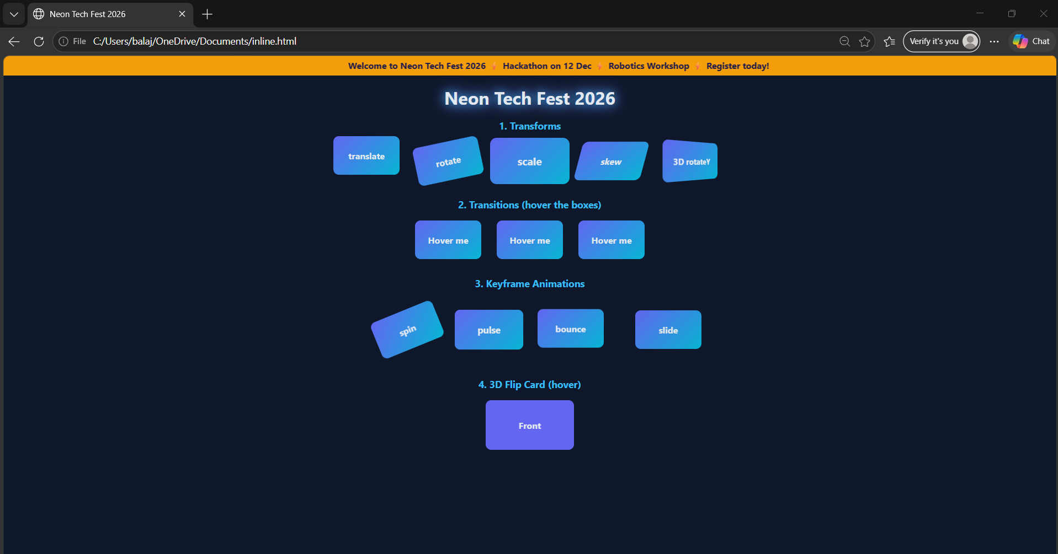
Fig 4.1: Neon Tech Fest page with the marquee scrolling and the animations running
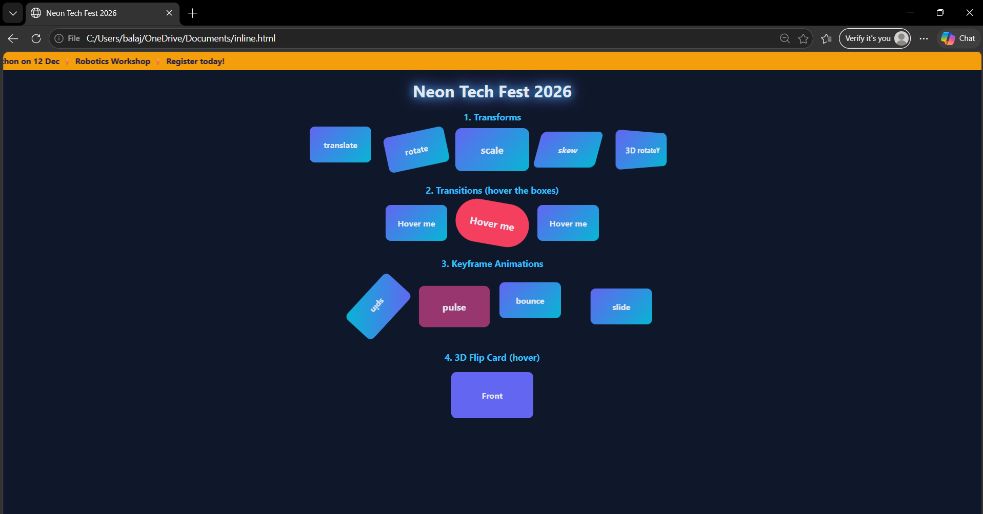
Fig 4.2: Transition on hover (top) and the 3D flip card turned to its back face (bottom)
How the keyframe animations work
- Step 1: define the steps, for example @keyframes pulse { 0%, 100% { transform: scale(1); } 50% { transform: scale(1.25); background: #ec4899; } }.
- Step 2: attach it to the element: .pulse { animation: pulse 1.5s ease-in-out infinite; }.
- Step 3: the browser creates the in-between frames, so the box grows and turns pink at 50% and returns at 100%.
- The same method gives the spin, bounce and slide boxes, the glowing title and the marquee scroll.
Explanation of the output
Section | Technique and result
Marquee bar | scroll keyframes move the text with translateX; it pauses on hover.
1. Transforms | translate, rotate, scale, skew and a 3D rotateY with perspective are applied directly to the boxes.
2. Transitions | On hover the box rotates, scales, becomes rounder and turns red over 0.6 seconds, and returns smoothly.
3. Animations | spin, pulse, bounce and slide run continuously with @keyframes.
4. Flip card | preserve-3d, perspective and backface-visibility: hidden flip the card by 180 degrees on hover to show the back face.

Note: transform and opacity are the best properties to animate because the browser can handle them without recalculating the layout, so the animation stays smooth.

Question 5: Architecture, Features and Working of Progressive Web Applications (PWA)
Design an architecture, features and working principles of Progressive Web Applications (PWA). Discuss the roles of service workers, web app manifests, caching strategies and push notifications in providing an enhanced user experience. (10 marks, CO1, BL3)
SOLUTION:
From web pages to web apps. Traditional websites are easy to reach through a link but depend on a good network and feel less smooth than installed apps. Native apps are fast and can work offline, but they must be downloaded from an app store, written separately for each platform and updated by the user. The term Progressive Web App was introduced by Frances Berriman and Alex Russell in 2015 for web applications that combine the reach of the web with the experience of native apps.
Aspect | Traditional website | Native app | Progressive Web App
Installation | None | App store download | Add to home screen from the browser
Offline use | No | Yes | Yes, with a service worker
Push notifications | No | Yes | Yes (support varies by platform)
Development | One web code base | Separate code for each platform | One web code base
Updates | Instant on the server | User must update | Automatic in the background
Discoverability | Search engines and links | App store only | Search engines, links and install

The app shell model. A PWA separates the minimum HTML, CSS and JavaScript needed to draw the interface (the app shell) from the content. The shell is cached on the first visit, so later visits show the interface immediately, and the content is loaded afterwards from the cache or the network.
Installability criteria. For a browser to offer installation, a site normally needs to be served over HTTPS, include a web app manifest with name, icons and start URL, and register a service worker. Tools such as Lighthouse in Chrome DevTools audit a site against the PWA checklist and report performance, accessibility and best-practice scores.
Security and scope. Service workers are powerful because they can intercept network requests, so browsers allow them only on secure origins (HTTPS or localhost) and only for pages inside the worker's scope, which is the folder it is served from. A service worker follows the same-origin policy and cannot read the DOM directly.
Limitations. PWAs cannot reach every device feature that native apps can, and the level of support for installation, push notifications and background tasks differs between browsers and operating systems. Features should therefore be added progressively, with the site still working as a normal web page where they are missing.

A Progressive Web Application is a website built with standard web technologies that behaves like an installed app: it can be added to the home screen, works offline or on a poor network and can send push notifications, while still being opened through a URL. A sample PWA, BookNest (a reading-list app), is designed below.
(a) Architecture
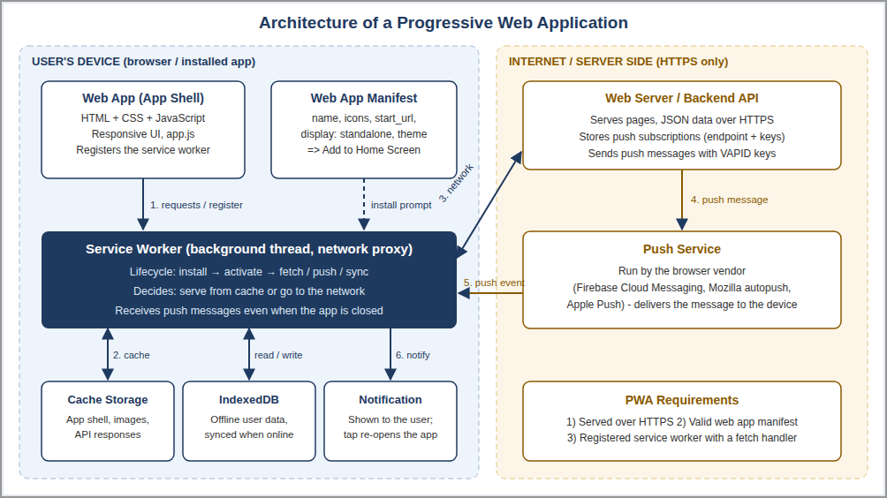
Fig 5.1: Architecture of a Progressive Web Application
Component | Role
Web app (app shell) | The HTML, CSS and JavaScript that draw the user interface. It loads instantly because the shell is cached, and registers the service worker.
Web app manifest | A JSON file that tells the browser the app's name, icons, start page and display mode, so it can be installed.
Service worker | A script running in the background that sits between the app and the network. It handles caching, offline use and push messages.
Cache Storage and IndexedDB | Cache Storage keeps files and responses; IndexedDB keeps structured user data for offline use and later synchronisation.
Backend and push service | The server provides data and sends push messages through the browser vendor's push service (for example Firebase Cloud Messaging).
HTTPS | Service workers and push work only on secure origins (localhost is allowed for testing).

Flow of the numbered arrows: (1) the app requests resources and registers the service worker; (2) the service worker reads or stores files in the cache; (3) if the file is not cached it goes to the network; (4) the server sends a push message to the push service; (5) the push service wakes the service worker with a push event; (6) the service worker shows a notification.
(b) Features of a PWA
- Reliable: loads instantly and works offline or on a weak network because of caching.
- Fast: the cached app shell gives quick start-up and smooth interaction.
- Engaging: can be installed on the home screen, opens full screen and can send push notifications.
- Responsive: one code base fits mobile, tablet and desktop screens.
- Secure: served over HTTPS, so content cannot be altered in transit.
- Discoverable and linkable: found by search engines and shared by URL, with no app-store approval.
- Progressive enhancement: works in every browser, and the advanced features are added where the browser supports them.
(c) Working principle
The service worker has its own life cycle:
- Register: the page calls navigator.serviceWorker.register("sw.js") after load.
- Install: the browser downloads sw.js and fires the install event, in which the app shell is pre-cached.
- Activate: the activate event fires when the worker takes control; old caches are deleted here.
- Fetch: every request from the page triggers a fetch event, and the worker answers from the cache or the network according to the chosen strategy.
- Update: when sw.js changes, the browser installs the new version in the background and activates it later, so users get the new version without reinstalling.
(d) Role of service workers
- A JavaScript file that runs in a separate background thread, has no access to the DOM and is event driven (install, activate, fetch, push, sync).
- Acts as a programmable network proxy, so the developer decides how every request is answered.
- Makes offline use possible, supports background sync and receives push messages even when the app is closed.
- Controls only the pages inside its scope and needs HTTPS.
(e) Role of the web app manifest
Field | Purpose
name, short_name | Full name for the install prompt and a short name under the home-screen icon.
start_url, scope | Page that opens on launch and the URLs that belong to the app.
display | standalone hides the browser address bar so the app looks native.
theme_color, background_color | Colour of the title bar and the splash screen.
icons | Icons in several sizes (for example 192 and 512 pixels) for the home screen and splash screen.

The manifest is linked from the page with <link rel="manifest" href="manifest.json">. Together with a service worker and HTTPS it makes the browser offer "Install app" / "Add to Home Screen".
(f) Caching strategies
Strategy | How it works | Best used for
Cache First | Look in the cache first and go to the network only if the file is missing. | Static files: CSS, JavaScript, images, fonts, app shell
Network First | Try the network first and use the cached copy when offline. | Frequently changing data such as API responses and news
Stale-While-Revalidate | Show the cached copy immediately and update the cache from the network in the background. | Avatars and content where fast display matters more than freshness
Network Only | Always use the network. | Payments, logins and other data that must not be cached
Cache Only | Always use the cache. | Pre-cached offline pages and the app shell

(g) Push notifications
- Permission: the app asks the user with Notification.requestPermission().
- Subscribe: the app calls pushManager.subscribe() with the server's public VAPID key and receives a subscription (endpoint and keys), which is sent to the server.
- Send: when there is news, the server sends a message to the endpoint at the browser vendor's push service.
- Receive: the push service delivers it and the browser wakes the service worker, even if the app is closed, to run the push event.
- Display and click: the worker calls showNotification(); on a tap the notificationclick event opens the app.
The Notification API shows a notification created by the page, while the Push API receives messages sent from the server; together they bring users back to the app.
(h) Enhanced user experience
Technology | Benefit to the user
Service worker and cache | Pages open instantly and keep working with no network, which removes the "no internet" error page.
Web app manifest | App icon on the home screen, a splash screen and full-screen mode give an app-like feel without an app-store download.
Caching strategies | Static files load from the device (less mobile data); fresh data is still fetched when online.
Push notifications | Timely updates such as offers or reminders, which improve re-engagement.

(i) Implementation of the sample PWA
manifest.json:
{
"name": "BookNest - Reading List",
"short_name": "BookNest",
"start_url": "./index.html",
"scope": "./",
"display": "standalone",
"orientation": "portrait",
"background_color": "#ffffff",
"theme_color": "#1f3a5f",
"icons": [
{ "src": "icon-192.png", "sizes": "192x192", "type": "image/png" },
{ "src": "icon-512.png", "sizes": "512x512", "type": "image/png", "purpose": "any maskable" }
]
}

sw.js (service worker):
const CACHE = "booknest-v1";
const SHELL = ["./", "index.html", "app.js", "manifest.json", "icon-192.png"];

// INSTALL: pre-cache the app shell
self.addEventListener("install", e => {
e.waitUntil(caches.open(CACHE).then(c => c.addAll(SHELL)));
self.skipWaiting();
});

// ACTIVATE: delete old caches
self.addEventListener("activate", e => {
e.waitUntil(caches.keys().then(keys =>
Promise.all(keys.filter(k => k !== CACHE).map(k => caches.delete(k)))));
self.clients.claim();
});

// FETCH: network-first for API calls, cache-first for everything else
self.addEventListener("fetch", e => {
if (e.request.method !== "GET") return;
const url = new URL(e.request.url);
if (url.pathname.startsWith("/api/")) {
e.respondWith(fetch(e.request).then(res => {
const copy = res.clone();
caches.open(CACHE).then(c => c.put(e.request, copy));
return res;
}).catch(() => caches.match(e.request)));
} else {
e.respondWith(caches.match(e.request).then(hit => hit || fetch(e.request)));
}
});

// PUSH: show a notification sent by the server
self.addEventListener("push", e => {
const d = e.data ? e.data.json() : { title: "BookNest", body: "You have a new update" };
e.waitUntil(self.registration.showNotification(d.title, { body: d.body, icon: "icon-192.png" }));
});
self.addEventListener("notificationclick", e => {
e.notification.close();
e.waitUntil(clients.openWindow("./"));
});

app.js (registration, status and notification):
const $ = id => document.getElementById(id);

function showNetwork() {
$("net").textContent = navigator.onLine ? "Online" : "Offline - loaded from cache";
$("net").className = navigator.onLine ? "pill ok" : "pill off";
}
window.addEventListener("online", showNetwork);
window.addEventListener("offline", showNetwork);
showNetwork();

$("manifest").textContent = document.querySelector('link[rel="manifest"]') ? "Linked" : "Missing";

if ("serviceWorker" in navigator) {
window.addEventListener("load", async () => {
const reg = await navigator.serviceWorker.register("sw.js"); // REGISTER
await navigator.serviceWorker.ready;
$("sw").textContent = "Active, scope: " + new URL(reg.scope).pathname;
const names = await caches.keys();
const files = names.length ? (await (await caches.open(names[0])).keys()).length : 0;
$("cache").textContent = names[0] + " (" + files + " files)";
});
}

$("notify").addEventListener("click", async () => {
const permission = await Notification.requestPermission(); // ask the user
if (permission === "granted") {
const reg = await navigator.serviceWorker.ready;
reg.showNotification("BookNest", { body: "New book added to your list!", icon: "icon-192.png" });
// Real push: reg.pushManager.subscribe({ userVisibleOnly: true, applicationServerKey: VAPID_PUBLIC_KEY })
}
});

index.html:
<!DOCTYPE html>
<html lang="en">
<head>
<meta charset="UTF-8">
<meta name="viewport" content="width=device-width, initial-scale=1.0">
<meta name="theme-color" content="#1f3a5f">
<title>BookNest PWA</title>
<link rel="manifest" href="manifest.json">
<link rel="icon" href="icon-192.png">
<style>
body { font-family: Arial, sans-serif; margin: 0; background: #f4f7fb; color: #1b2733; }
header { background: #1f3a5f; color: #fff; padding: 14px 20px; display: flex; justify-content: space-between; align-items: center; }
header h1 { margin: 0; font-size: 1.3rem; }
main { max-width: 560px; margin: 0 auto; padding: 16px; }
.pill { padding: 3px 12px; border-radius: 12px; font-size: .85rem; }
.ok { background: #c8f2d4; color: #14532d; } .off { background: #fde2c8; color: #7c2d12; }
ul, table { background: #fff; border-radius: 8px; box-shadow: 0 1px 4px rgba(0,0,0,.15); }
ul { padding: 12px 12px 12px 32px; } table { width: 100%; border-collapse: collapse; }
td { padding: 8px 12px; border-bottom: 1px solid #e5eaf0; } td:first-child { font-weight: bold; width: 35%; }
button { margin-top: 14px; padding: 9px 18px; border: 0; border-radius: 6px; background: #1f3a5f; color: #fff; cursor: pointer; }
</style>
</head>
<body>
<header><h1>BookNest</h1><span id="net" class="pill">...</span></header>
<main>
<h2>My Reading List</h2>
<ul><li>Wings of Fire</li><li>Clean Code</li><li>The Alchemist</li></ul>
<h3>PWA Status</h3>
<table>
<tr><td>Manifest</td><td id="manifest">Checking...</td></tr>
<tr><td>Service worker</td><td id="sw">Registering...</td></tr>
<tr><td>Cache storage</td><td id="cache">Checking...</td></tr>
</table>
<button id="notify">Enable notifications</button>
</main>
<script src="app.js"></script>
</body>
</html>

OUTPUT:
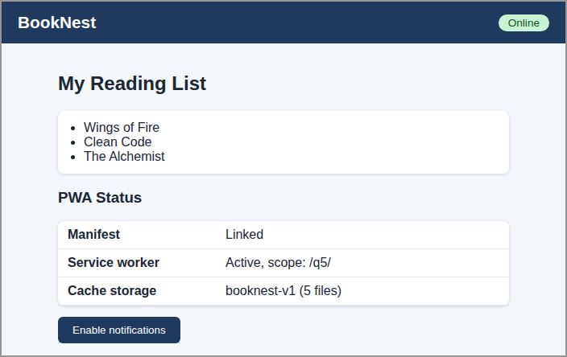
Fig 5.2: BookNest running online - manifest linked, service worker active, cache created
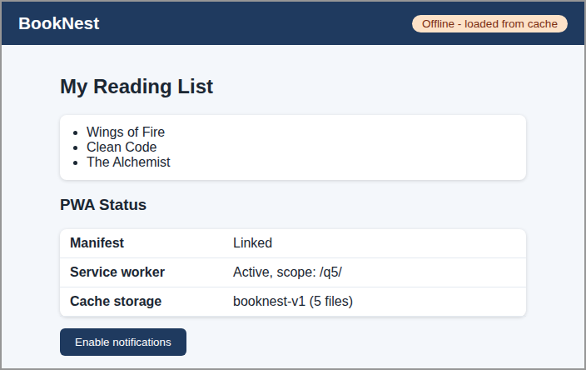
Fig 5.3: The same page reloaded with the network switched off - still loads from the cache
Explanation of the output
- The page was served from localhost (service workers need HTTPS or localhost). The status table shows that the manifest is linked, the service worker is active for the app's scope and the cache booknest-v1 holds the 5 pre-cached files.
- After the network was switched off and the page reloaded, it still opened because sw.js answered from the cache, and the badge changed from Online to Offline.
- Push messages need a real server with VAPID keys, so the sample shows only the client-side code for notifications.
Conclusion: a PWA combines a manifest, a service worker and HTTPS to give a website the speed, reliability, installability and engagement of a native app, using one web code base.
Code of Conduct:
I B KIRTHANAA 192324244 certify that this submission is my original work and that I have adhered to the guidelines specified for this assessment. I understand that any violation of academic integrity rules will result in disciplinary action.
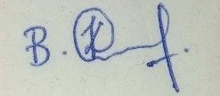
Signature of the student: B KIRTHANAA

